**Bug Report**

**Date:**09/07/2023

**Tested by:**Saima Sharoni

**Tested website:**<https://test-shop-57100.myshopify.com/>

**Environment**: Chrome browser

**Bug Report 1**

* Title: Delete items from cart
* Bug details:When the delete button is clicked the loading goes on without removing the item from the cart.
* Steps to reproduce:

1. Open the website link
2. Add an item to the cart
3. Click the cart icon on top of the right side
4. Click the delete button

* Screenshots or other evidence: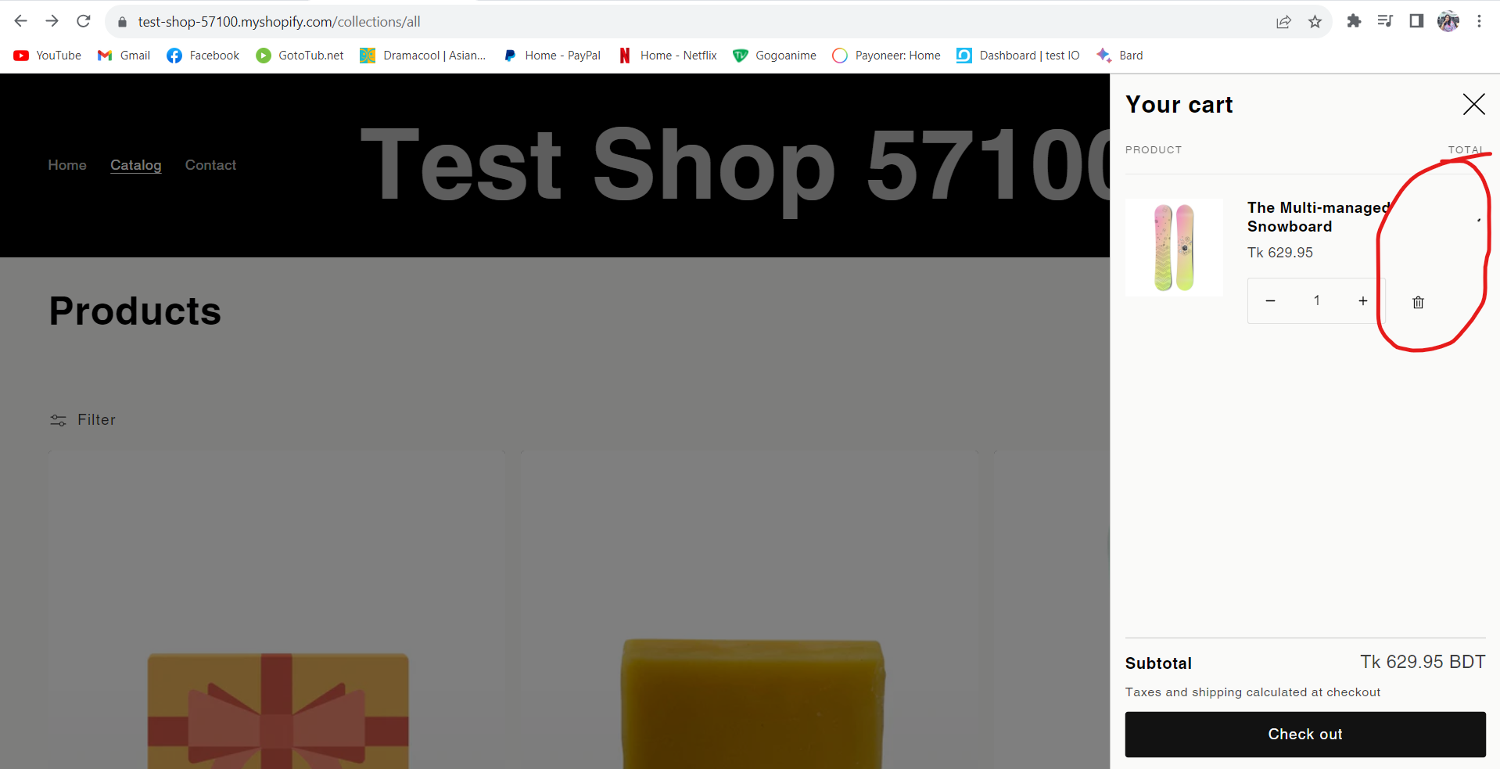
* Severity: Major
* Priority: High
* Reporter:

**Bug Report 2**

* Title: Item increase
* Bug details:When the plus button is clicked the item quantity does not increase.
* Steps to reproduce:

1. Open the website link
2. Add an item to the cart
3. Click the cart icon on top of the right side
4. Click the plus button

* Screenshots or other evidence: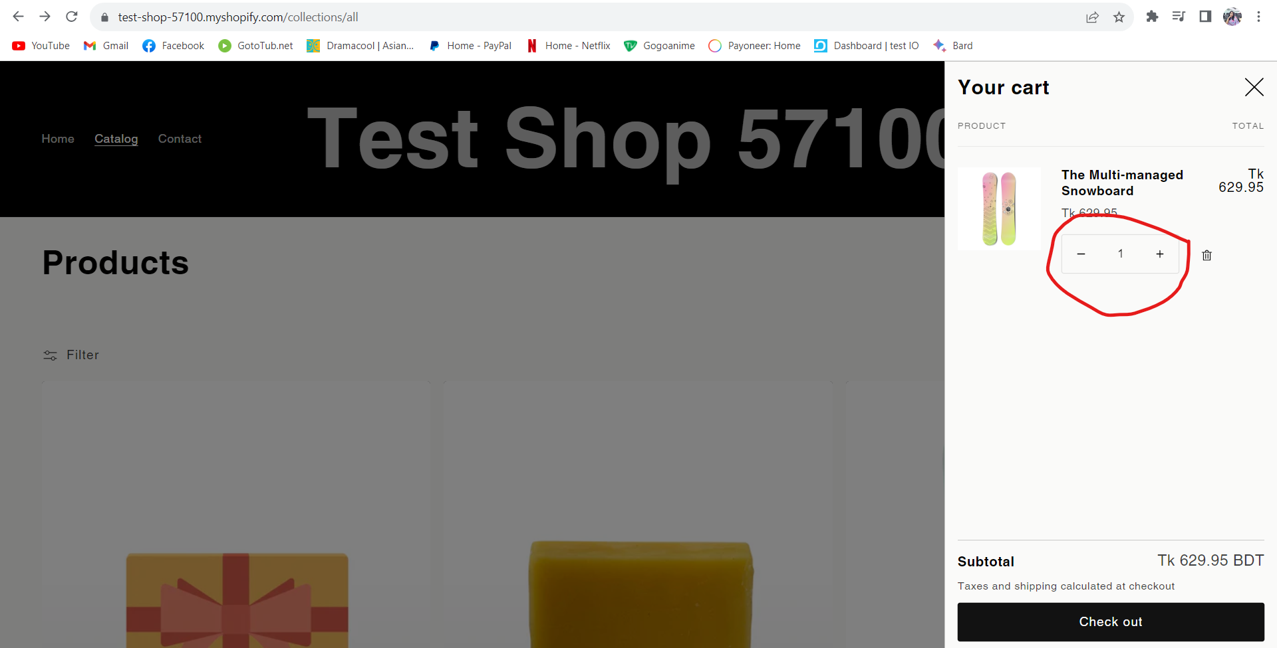
* Severity: Major
* Priority: High
* Reporter:

**Bug Report 3**

* Title: Home page hang
* Bug details:When the plus button is clicked the item quantity does not increase.
* Steps to reproduce:

1. Open the website link
2. Add an item to the cart
3. Click the cart icon on top of the right side
4. Click the plus button
5. Click the delete button
6. Try to stroll down

* Screenshots or other evidence: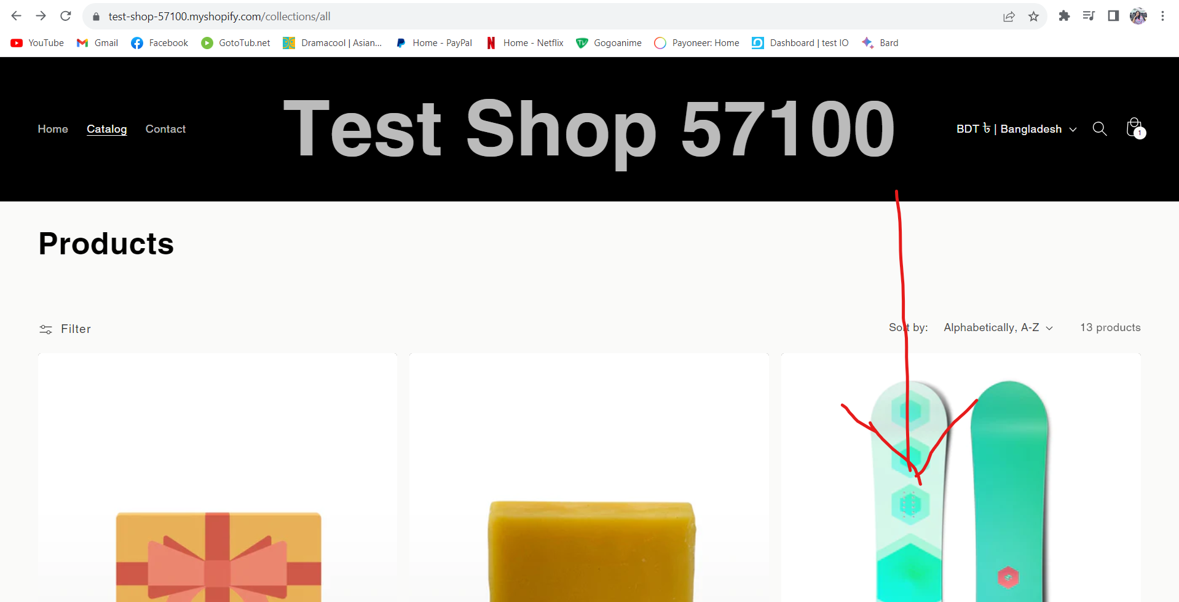
* Severity: critical
* Priority: high
* Reporter:

**Bug Report 4**

* Title: The slider button is not working
* Bug details:The slider button from the Featured products option is not working.
* Steps to reproduce:

1. Open the website link
2. Go to the Featured products section
3. Click the next button

* Screenshots or other evidence: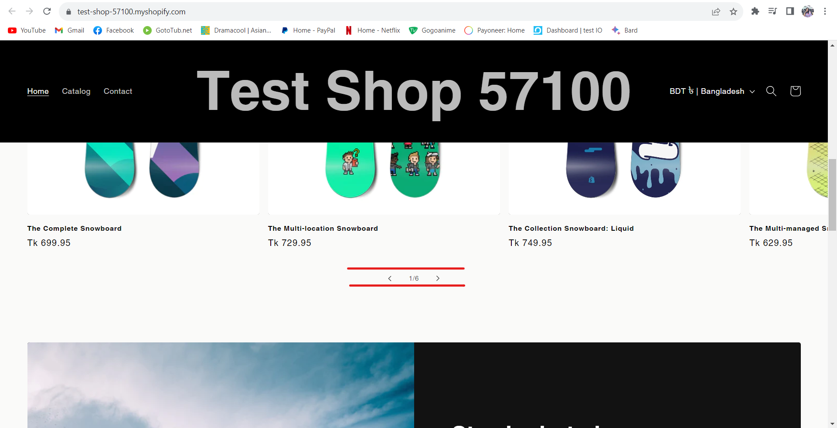
* Severity: Minor
* Priority: Medium
* Reporter:

**Bug Report 5**

* Title: DropDown button is not showing any option
* Steps to reproduce:

1. Open the website link
2. Click the DropDown button icon from top of the left side.

* Screenshots or other evidence: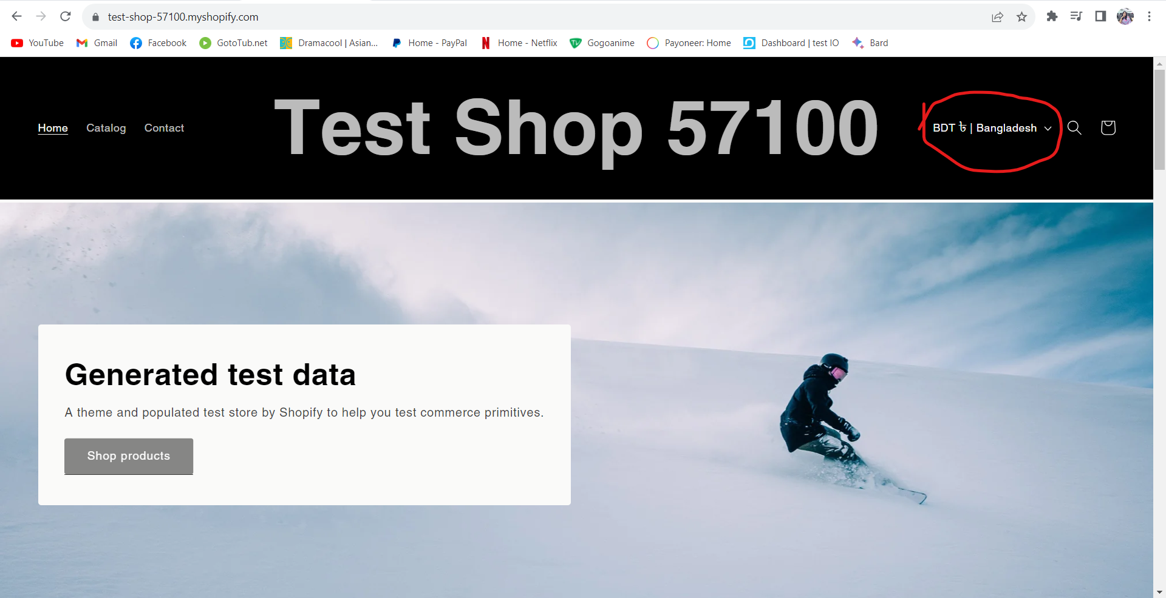
* Severity: Major
* Priority: High
* Reporter: